**RAJALAKSHMI ENGINEERING COLLEGE**

**RAJALAKSHMI NAGAR, THANDALAM – 602 105**



|  |
| --- |
| **CS23A34**  **USER INTERFACE AND DESIGN LAB** |
| **Laboratory Observation NoteBook** |

|  |
| --- |
| **Name :D L** PRAVEENKAANTH  **Year/Branch/Section :** II/CSE/D  **Register No. :** 230701399  **Semester :** IV  **Academic Year:** 2024-25 |

**Ex. No.** **: 4a**

**Register No. : 230701399 Praveenkaanth**



**Conduct task analysis for an app (e.g., online shopping) and**

**document user flows. Create corresponding wireframes using Lucidchart**

**AIM:**

To understand and document the steps a user takes to complete the main tasks within an online shopping app.

**PROCEDURE:**

Tool Link: https://www.lucidchart.com/pages/

**Step 1: Assigning Tasks**

1. Browsing Products

2. Searching for a Specific Product

3. Adding a Product to the Cart

4. Checking Out

**Step 2: Document User Flows**

1. Browsing Products

1. Home Screen: User lands on the home page with product categories.

2. Product Categories: User taps on a category to view products.

3. Product List: User scrolls through the product list.

4. Product Details: User taps on a specific product to see details.

Home Screen -> Product Categories -> Product List -> Product Details

2. Searching for a Specific Product

1. Search: User taps the search bar or icon.

2. Enter Query: User types the product name or keyword.

3. Search Results: User reviews matching items.

4. Product Details: User taps on a specific product to see details.

Search ->Enter Query -> Search Results -> Product Details

3. Adding a Product to the Cart

1. View Products: User browses or searches for a product.

2. Product Details: User taps on the product to see more info.

3. Add to Cart: User clicks “Add to Cart”

View Products ->Product Details -> Add to Cart

4. Checking Out

1. Open Cart: User taps on the cart icon.

2. Review Cart: User checks all products.

3. Proceed to Checkout: User clicks “Checkout”

4. Enter Shipping Info: User provides shipping details.

5. Enter Payment Info: User provides payment details.

6. Place Order: User clicks “Place Order”

Open Cart -> Review Cart -> Proceed to Checkout -> Enter Shipping Info -> EnterPayment Info ->Place Order

**Step-by-Step Procedure to Create User Flows in Lucidchart**

1. Create a New Document

● Go to Lucidchart and sign in or sign up if you don’t have an account.

● Click on + Document or Create New Diagram.

2. Select a Template

● You can start with a blank document or select a flowchart template.

● For this example, let’s start with a blank document.

3. Add Shapes for Each Step

● Drag and drop shapes from the left sidebar to represent different steps in your

flow (e.g., rectangles for actions, diamonds for decisions).

● Name each shape based on the steps from the task analysis:

○ Login/Register

○ Browsing Products

○ Adding Products to Cart

○ Managing Cart

○ Checkout Process

○ Tracking Orders

4. Connect the Shapes

● Use connectors to link the shapes, indicating the flow from one step to the next.

● Add arrows to show the direction of the flow.

5. Add Details to Each Step

● Double-click on each shape to add text describing the action or decision.

● For example, for the “Login/Register” step, you might add:

○ Open the app

○ Click on “Sign Up” or “Login”

○ Enter details (username, email, password)

○ Click “Submit”

○ Verification through email or phone (if required)

○ Redirect to the home screen upon successful login

6. Use Different Shapes for Different Actions

● Use rectangles for general actions.

● Use diamonds for decision points (e.g., “Is the user logged in?”).

● Use ovals for start and end points.

7. Customize and Organize Your Flowchart

● Arrange the shapes and connectors logically.

● Use different colors to distinguish between types of steps or user roles.

● Group related steps into sections for better clarity.

8. Review and Save Your Flowchart

● Review the flowchart to ensure all steps are included and connected correctly.

● Save your flowchart by clicking on File -> Save.

9. Share and Collaborate

● Click on the Share button to collaborate with others.

● You can also export your flowchart as an image or PDF for presentation

Purposes.

**Example Flowchart Breakdown:**

Login/Register Flow

● Steps:

○ Open the app

○ Click on “Login” or “Register”

○ Enter details

○ Verify (if required)

○ Redirect to the home screen

Browse and Search Flow

● Steps:

○ Navigate to categories or use search bar

○ Apply filters/sorting options

○ View product details

Add to Cart Flow

● Steps:

○ View product details

○ Select options (size, color, quantity)

○ Add product to cart

Checkout Flow

● Steps:

○ Review cart

○ Proceed to checkout

○ Enter shipping information

○ Select payment method

○ Confirm and place order

Order Tracking Flow

● Steps:

○ Navigate to “My Orders”

○ Select order to track

○ View tracking details

**Output :**

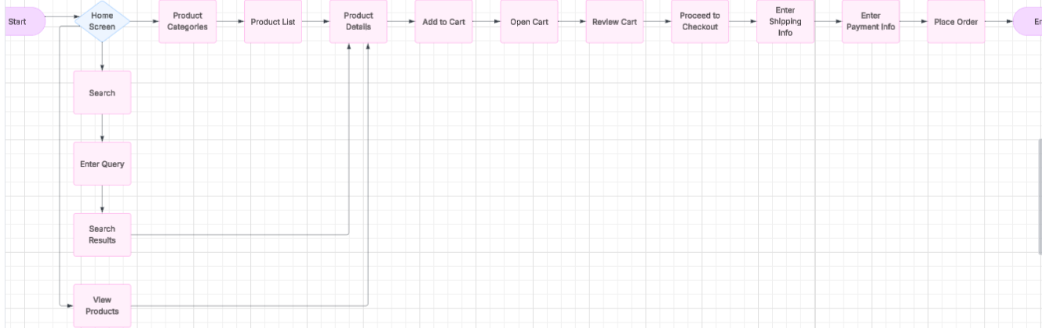

**Result :**

Hence, creating a prototype with familiar and unfamiliar navigation and using different user groups using prto.io has been successfully executed.